**1.2 Background**

For many individuals, including myself, going to the cinema is a great source of entertainment, but many believe it’s a terrible place to watch movies nowadays. The atmosphere is ideal, the screen is big, the sound and resolution are top quality [1]. Furthermore, arcade games and canteens are installed to provide additional entertainment and delicious snacks. Then what makes it undesirable for certain people? Comfort and cost are great factors that affect the overall movie experience from the moment the consumer enters the cinema.

**1.2.1 Comfort**

A great majority prefers watching movies in the comfort of their own house. No costs required, no specified time intervals and most importantly, no distractions and no crowded rooms. In a cinema, possibly hundreds of people are watching the movie in the same room as you [2]. Therefore, everyone must be silent and polite. It can become a challenge when the room contains small children and other individuals who overreact while watching a movie. To certain people, this is a great annoyance. Watching the movie at home alone allows to create the ideal atmosphere, mood and setting an individual desires. You can scream, you can remain silent, you do what you prefer at the end of the day. Another major fallback is commercials and breaks. A lot of viewers would prefer watching a movie straight away from finish to start without any commercial breaks [2]. Other viewers want a certain time interval to relax, refill food, go for a bathroom break. A cinema does not account for any of these preferences. Therefore, such cinema standards can diminish the movie experience.

**1.2.2 Cost**

The ticket cost nowadays for an IMAX movie can reach over 20 Canadian Dollars in local Canadian cinemas. Ticket prices have skyrocketed and a lot of viewers prefer to buy the Blu-Ray disk or download the movie for free or stream it online and watch it as many times as preferred [2]. Not only this hurts the cinema’s business models, but also the film industry as a whole. The industry cannot adapt to such getaways, where viewers believe that the cinema experience will not overcome the cheapest, the fastest and the easiest way to watch movies. At the end of the day, watching a movie from the screen of a laptop has the same, if not, higher value as watching it on a costly bigger screen somewhere else.

**Mega Movie Theatre**

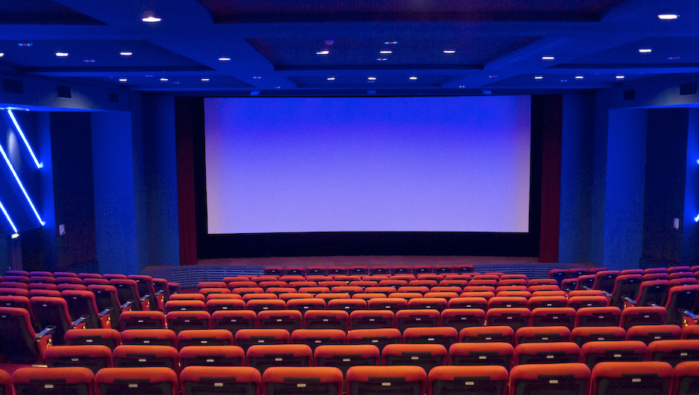

**Figure 1 |** **Mega Movie Theatre [1]**

**1.3 Scope**

The plan is to reach and reform as many theaters as possible across all countries where Cinema is a major part of entertainment. Countries like China and the USA are countries where the film industry produces the most revenue. In addition, virtual reality is another big component of entertainment in these two countries. Therefore, combining both of these assets will bring major changes to these two regions. In Canada, cinema is also a major source of entertainment, especially in Montreal and Toronto. To facilitate budget ranges and initial executions, the scope in the beginning will remain within regional cinemas of Montreal. *Cinepolis* and *Cinema Guzzo* are great candidates for initializing this campaign. For a starting point, they can build an additional room with this new experimental technology. The *Guzzo Mega-Plex SPHÈRETECH 14* in Montreal is an ideal location due to their wide and affordable space.

**2.0 SOLUTION**

Virtual reality is an ideal candidate for improving the cinematic experience in many aspects. To rightfully approach such an idea, an initial concept must be established. The virtual reality headset, paired with build-in headphones are the main components required [8]. This results to the big screen and the amphitheater rooms becoming obsolete, which allows for smaller and less costly space for a cinema. Although this will appear odd for the public at first, by focusing on the overall quality of the virtual reality screening, it will be later overlooked.

**Complete Headset for VR experience**

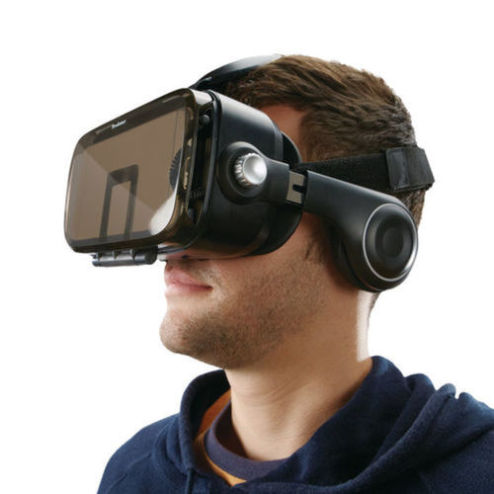

**Figure 2 | Complete Headset for VR experience [8]**

**2.1 Virtual Reality Integration**

The virtual reality is a two-or-three-dimensional computer-generated environment where it can be interacted with special tools and equipment. For this concept, the headset is the only necessary wearable component since the viewer will interact with the movie only by head tracking [4]. Therefore, the viewer input will only have a parameter of 360 degrees rotation from all three axis of the plane. The goggles are a wearable tech piece where an elastic strap holds both of its sides together. This allows for the head of the viewer to be wrapped properly and keep the headset rigid [8]. It is composed of a case, a screen base and universal output system [3]. The case is a plastic, hard-surfaced, smooth cover, which encloses and stores the rest of the components. The screen base contains the plastic, shiny lenses and other electronic parts which screen the desired input. There are different bases with different lenses. There is a 2D, a 3D and a Virtual/Augmented reality base [3]. The 2D base is the only base without double lenses. The universal output system is a layer within the casing that consists of different gates and porting options for the desired screening base. Certain headsets contain gates for mobile devices, where the screening base is replaced. The devices will be connected to the viewer’s chair, where a central control unit connects all chairs in the room for viewing the movie simultaneously. In addition, having a pre-existing headphone connected to the headset will facilitate the manufacturing process and the budget management.

**Virtual Reality Headset Anatomy**

[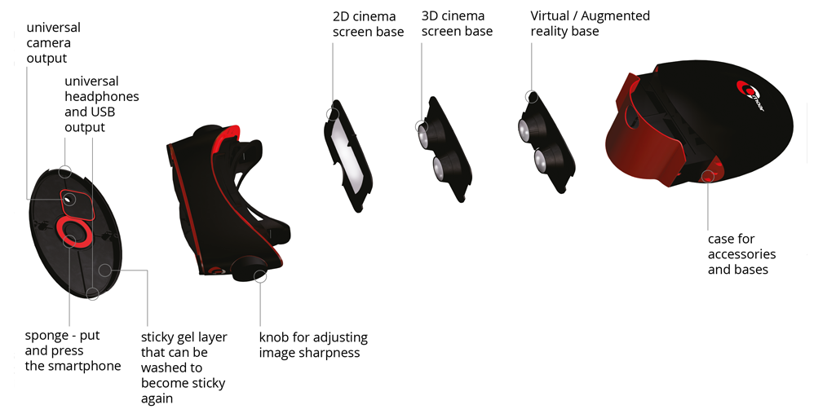](cmoar-exploded.png)

**Figure 3 |** **Virtual Reality Headset Anatomy [3]**

**2.2 Environment Design**

The rooms must be structured in a way that minimizes sound disturbance and provide comfort for the viewers. For maximizing sound proofing, there will be sound absorbing panels in the walls. They must be pyramid shaped with a black Styrofoam material [5]. The surface results to an extremely rough finish, which prevents the sound from entering or exiting the room respectively. Additionally, the wall structure as well must be sound proof. Cellulose insulation and drywall are core strategies of soundproofing a wall. Increasing the thickness and rigidness on all sides will ensure total tranquility in the environment. An array of comfortable and wide chairs will be placed within the room, where each chair has its own equipment and additional controls for personal preferences when it comes to adjusting sound volume and screen brightness. The chairs will be connected to a central unit, located in a booth, where a powerful computer will be controlling the movie screening. A series of cable networks must provide the highest performance of real-time screening within the entire room, to ensure that all viewers are screening the movie simultaneously with minimal latency and errors.

**Studio Acoustic Styrofoam – Pyramid Shaped**

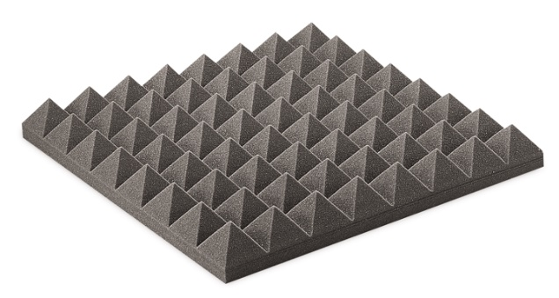

**Figure 4 |** **Studio Acoustic Styrofoam – Pyramid Shaped [5]**

**2.3 Result**

In general, having a headset ensures the users are watching the movie in their own terms and disconnect from the outside world. Virtual Reality has proven to be efficient and reliable, therefore, implementing this strategy on cinemas will not result in major technical failures. By encasing the audience on their own screening and sound, the distractions between them are minimal. Since the big screen is removed, the amphitheater structure of the room is not needed anymore. This can save space vertically, providing extra rooms in additional floor levels for a larger audience number. In the end, saving space also reduces costs for the organization, meaning the ticket cost will also decrease significantly.

**3.0 PLAN OF ACTION**

Such a complicated idea cannot be executed without efficient and strategic preparation. There are three core phases that must be implemented for a successful outcome: researching or improving existing high-definition real-time 2D/3D video renders, maintaining equipment by training staff and users, and constructing new rooms ideal for installing the equipment.

**3.1 Virtual Reality Research and Development**

Virtual reality today provides a variety of options for screening movies, games or anything else in real-time. This concept relies on user immersion, so 360 real-time rendering is the desired option. This means that the movie is being rendered on the spot, requiring no previous rendering from the movie production also reducing the cost and time interval of post-production [4]. The cameras used for the film production will provide a 360 view of the scene, where the viewer’s head tracking changes the camera angle in the movie.

**3.2 Equipment Maintenance**

The maintenance personnel within the cinema must be trained to fix and maintain the equipment and headgear both hardware and software wise. Before and after every screening, quick tests have to be made to ensure the equipment provides no issues while the movie plays.

**3.3 Room Construction and Optimization**

Decreasing the room size allows the cinema to downsize and reduce building costs. Either a complete overhaul of the location must be made or a new one with special rooms must be constructed. In this case, building a new experimental cinema is the cheapest approach.

**4.0 SCHEDULE**

The schedule of this proposing concept is separated into eight core aspects. The project will ideally have a span of 4 to 5 months. The Research and Development of the virtual reality screening will start from January 15th and end on March 1st. During this time period, a team of engineers will optimize the virtual reality goggles to screen in real time high resolution of 360 movies and integrate 3D high quality sound from headphones. From February 1st to March 20th, the room overhaul in the cinema will take place. An additional room will be constructed to a cinema that can afford the space and resources. From February 15th to March 25th, the manufacturing of the headgear and the rest of the required equipment will occur, which happens after the research and development has completed relatively most of the work. From February 20th to March 15th, the central booth will be constructed. The central computers and servers of the room will be installed from March 10th to March 25th. The chairs will be installed between March 15th and April 1st after most of the equipment has been manufactured. After all the constructions, the testing and training periods will occur until the beginning of May.

**Table 1 | Gantt Chart of the Project’s Scheduling**

**5.0 BUDGET**

The budget is separated into three core parts. First, the management will have an amount disposed for controlling the entire operation and how the process moves. Second, the salary of the workers will majorly contribute to the budget. Third, the equipment and material will have the largest impact on the overall budget. The total budget accumulates to 755 000 CND.

**5.1 Management**

The management budget is split into three categories: project, which includes myself, investment and IT management. An estimate of 100 000 CND or 13% of the overall budget will be spent for the project management. It is a great amount for sustaining a great team [6].

|  |  |
| --- | --- |
| **Management Type** | **Assigned Budget (in CND)** |
| Project Management | 40 000 |
| Investment Management | 40 000 |
| IT Management | 20 000 |

**Table 2. Management Budget**

**5.2 Salary**

The salary consists of the overall cost spent on workers for the entire project. Researchers, software engineers, manufacturers, architects, builders, designers and more will get paid for the entire period of the project. Training staff corelates to the normal salary of the cinema employee. The salary will accumulate up to 360 000 CND or 48% of the budget, which is a high percentage for projects like these. This also includes bonuses, commissions and all taxes [6].

|  |  |
| --- | --- |
| **Worker Type** | **Assigned Salary Budget (in CND)** |
| Software Engineers | 100 000 |
| Hardware Specialists and Manufacturers | 100 000 |
| Transportation | 10 000 |
| Building Engineers | 120 000 |
| Interior Designers | 50 000 |

**Table 3. Salary Budget**

**5.3 Equipment and Materials**

The rest of the budget, which is 295 000 CND, is estimated to go to the installations, research and materials provided. The room construction will contain a variety of materials, which is everything from room insulations and design to chair and headset manufacturing. The rest will be spent to the research of the software and hardware required.

|  |  |
| --- | --- |
| **Equipment** | **Assigned Budget (in CND)** |
| VR Headgears (Complete Set) | 25 000 |
| Wall Cement | 100 000 |
| Insulations | 20 000 |
| Computers and Cables | 25 000 |
| Sound Absorption Foam Panels | 35 000 |
| LED Lights | 15 000 |
| Cinema Chairs | 75 000 |

**Table 4. Equipment and Material Budget**

**6.0 QUALIFICATIONS**

Qualified personnel and companies will be hired to manage and control such ambitious project. I will personally lead the overall management of the project. Unity Technologies, a computer graphics company located in Montreal will manage everything related to software and hardware, specifically everything needed for the virtual reality integration in the cinema.

**6.1 George Mavroeidis**

I am a Computer Science Major in Concordia University specializing in Computer Games. The idea of the virtual reality integration to cinema sparked from playing games with a VR headset. It was such an immersive experience and I could not forget the first time I put that headset over my head and witnessed such a roller coaster of emotions. If something like this already exists for games, it can possibly work for mainstream cinema releases as well. I will be responsible for managing the entire process and making sure the concept is brought to life the right way.

**6.2 Unity Technologies**

Unity Technologies is an organization that provides software solutions for various industries such as gaming, film, automotive and more [7]. They work closely with virtual/augmented reality technologies and other graphic techniques. In this project, they will be responsible for the research and development of the required technologies and providing the blueprints and the mechanics for the equipment. Any software and hardware will be developed and approved by them, which will later be used for the manufacturing phase. Their budget share consists of IT management, software engineers or researchers, hardware specialists and computer parts.

**7.0 CONCLUSION**

The cinema experience has changed for the worse in the past century due to many advances in technology that make it easier and more comfortable to watch movies at home. Instead of cinemas trying to avoid this change, they should embrace it and use it as their advantage.

Virtual Reality is a relatively new concept which has assisted other industries with contemporary solutions to facilitate their progress. This can also work for the film industry by providing the audience with the immersion they’ve always strived for, which previous attempts by other technologies could not successfully do so. The headset consists of different parts that record user input and apply it to the fictional world inside it. This eliminates the need of a big screen and the amphitheater structure of the room. This results to saving more space, reducing building costs and ticket costs, making the audience reconsider their visit to the cinema. The room will consist of comfortable seats and a booth that screens the movie to all headsets, connected to each seat.

The schedule and a budget of 750 000 CND are well-organized to ensure the project’s workflow is properly organized and meets the deadline of four to five months without any missteps. Unity Technologies, a computer software company, will partner with me so I can provide the best quality of resources and knowledge to the workers. With confidence, the project promises to bring back the long, lost memories we experienced as a child during the prime era of the cinema world, which has remained in our hearts since. To get in touch with me, George Mavroeidis, email me at gdmavroeidis@hotmail.com or call me at (514) 978-6561.

**REFERENCES**

[1] P. Sciretta, *Daily Podcast: Is It Okay To Leave Trash In A Movie Theater? Talk During Trailers? Bootleg A Scene If You Have To Pee?*, Shlash Film, 2019. [image] Available at: <https://www.slashfilm.com/daily-podcast-is-it-okay-to-leave-trash-in-a-movie-theater-talk-during-trailers-bootleg-a-scene-if-you-have-to-pee/>. [Accessed: 10 Mar 2019].

[2] D. Reddish, *15 Reasons Why People Don't Go To The Movies Anymore*, ScreenRant, 2016. [Online] Available at: <https://screenrant.com/reasons-why-people-dont-go-to-the-movies-anymore-box-office/>. [Accessed: 9 Mar 2019].

[3] P. James, *E3 2014: Cmoar is a Mobile VR Viewer With Swappable Lenses.* [image] Available at: <https://www.roadtovr.com/e3-2014-cmoar-mobile-vr-viewer-swappable-lenses-video/> [Accessed: 8 Mar. 2019].

[4] S. Charara, *Explained: How does VR actually work?*, Wareable, 2017. [Online] Available at: <https://www.wareable.com/vr/how-does-vr-work-explained>. [Accessed: 8 Mar. 2019].

[5] MMT Acoustix, *Acoustic Foam in Kuwait*, n.d. [image] Available at: <http://mmtacoustix.com/acoustic-foam-kuwait.html>. [Accessed: 8 Mar. 2019].

[6] *Research Proposals - Budget | ORSP*, *University of Michigan*, 2019. [Online]. Available at: <https://orsp.umich.edu/research-proposals-budget>. [Accessed: 11 Mar 2019].

[7] Unity Technologies, *Unity3D*, 2019. [Online]. Available: <https://unity3d.com/>. [Accessed: 11 Mar 2019].

[8] Brookstone, *VR Headset with Built-In Headphones.* [image] Available at: [http://www.brookstone.com/pd/vr-headset-with-built-in-headphones/320195p.html](http://www.brookstone.com/pd/vr-headset-with-built-in-headphones/320195p.html%20) [Accessed: 11 Mar. 2019].